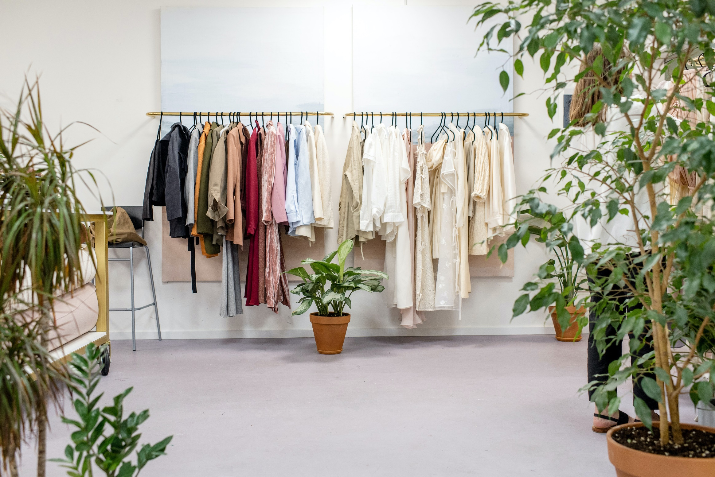
Sample conversation
Shopping assistant: Good afternoon. May I help you?
Customer: Yes please, I’m looking for a T-shirt.
Shopping assistant: Follow me please. What is you size?
Customer: Let me think….Medium I think.
Shopping assistant: What colour would you like?

Customer: I’m looking for a blue one.
Shopping assistant: Here ( while handing a piece of clothing) How about this one?
Customer: Hmmm, I’m not sure. Can I try it on?
Shopping assistant: Yes, of course. The fittingrooms are over there.

( some time later)

Customer: I think it’s a bit too small to my taste.
Shopping assistant: Okay. Let me see. I’m afraid we don’t have size L anymore. How about this one?
Customer: Well, I have to say I like this one better.

(Some time later)

Customer: It fits well and I like the print better! How much is this one?
Shopping assistant: That one is….Let’s have a look…. €19,95.
Customer: I’ll take it. Can I pay by debit card?
Shopping assistant: Of course. No problem. Here you go ( handing over the receipt) your receipt. Have a nice day.

AT A ( CLOTHING) SHOP
BELANGRIJK!
Je kunt:
- een gesprek netjes beginnen en eindigen.
- Fillers gebruiken. Kijk naar de woorden die onderstreept zijn. (kijk verder bij: hulp materiaal)
- woorden die je niet weet omschrijven.

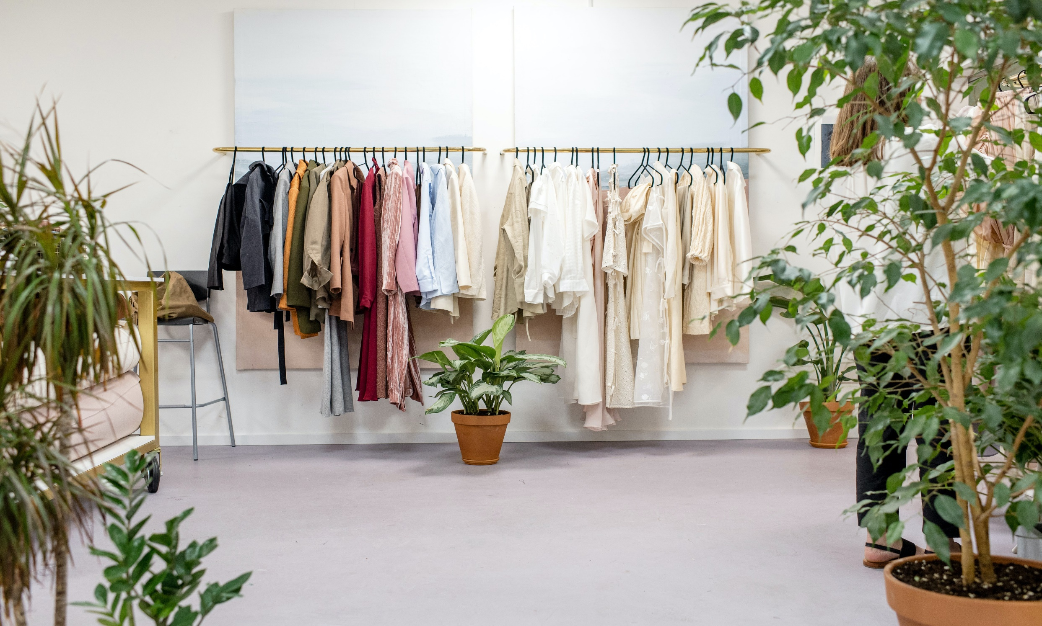
AT A (CLOTHING) SHOP
Situatie 1
KLANT
Je bent in een kleding winkel en je wilt een leren jas kopen. Je wil graag een bruine. Je hebt maar 34. Je vindt zwart ook wel mooi. Je bent onzeker welke kleur jou het beste staat. Laat dit merken. Je wil met een pinpas betalen.
WINKELBEDIENDE
Je bent een winkelbediende en je vindt jouw baan erg leuk. Laat dit merken. Je hebt alleen zwarte en bruine leren jassen. De bruine jassen heb je alleen in maat 40. De zwarte leren jassen heb je in maat 34 en 38. De bruine leren jas kost €150,- en de zwarte €155,- De klanten kunnen contant en met pinpas betalen.

Situatie 2
KLANT
Je bent in een kleding winkel en je wilt een zijde jurk kopen. Je bent opzoek naar een licht paarse jurk. Je hebt maar 40. Je houdt niet van oranje en je wil ook geen ander materiaal. Je bent onzeker of de kleur die de verkoper heeft jou wel staat. Laat dit merken. Je wil graag contant betalen.
WINKELBEDIENDE
Je bent een winkelbediende en je vindt jouw baan erg leuk. Laat dit merken. Je hebt voornamelijk katoenen jurken. Prijs deze aan. Probeer de klant te overtuigen een katoenen jurk te kopen. Voordelen: kreukt niet, goedkoop (€ 80,-) en sterk materiaal. Je hebt wel een paar zijde jurken, maar die zijn duur ( € 180,-)en je hebt alleen nog een donkerpaarse kleur. Klanten kunnen contant betalen.

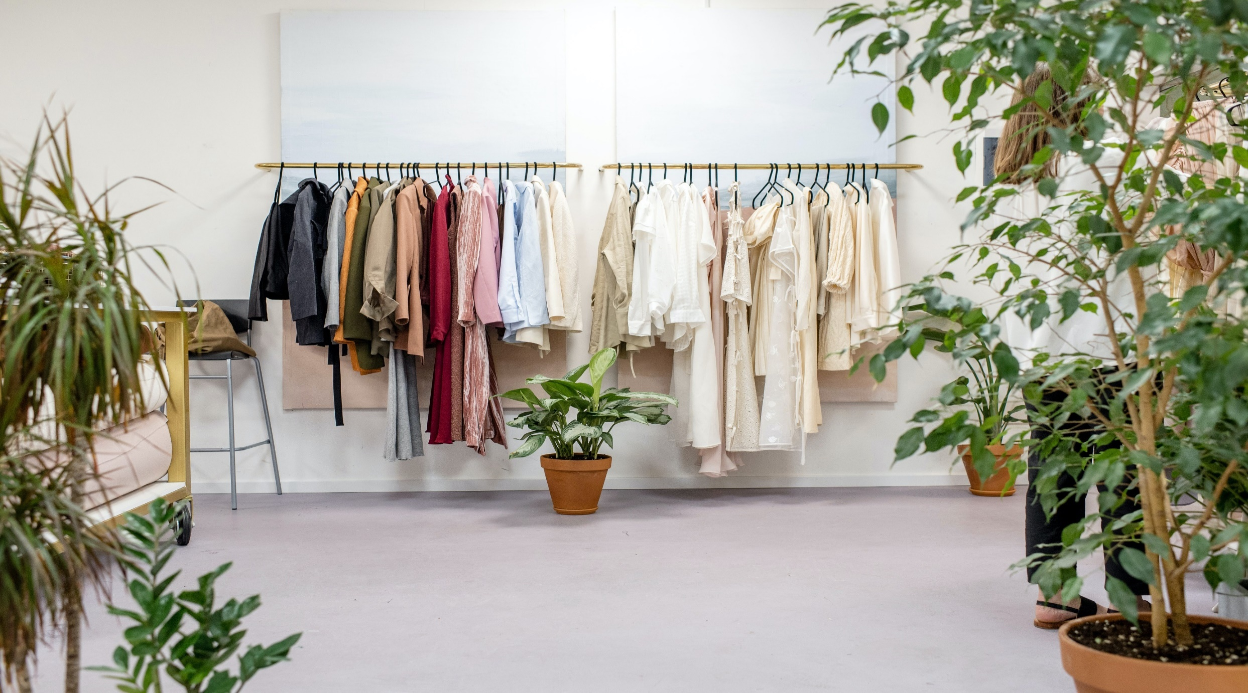
AT A (CLOTHING) SHOP
Situatie 3
WINKELBEDIENDE
Je bent een winkelbediende en je vindt jouw baan erg leuk. Laat dit merken. Je verkoopt ook wollen truien in elke kleur. De prijs varieert tussen de €30,- tot €80,- Je hebt ook een donkerblauwe spijkerbroek. Deze week zijn ze in de aanbieding. 2 voor de prijs van 1. Die kost € 70,- Je De klanten kunnen contant en met pinpas betalen.
KLANT
Je bent in een kleding winkel en je wilt een wollen trui en een spijkerbroek kopen. Je hebt € 100,-). Je zoekt een groene trui en een donkerblauwe spijkerbroek. Je hebt maar M. Je houd niet van spijkbroeken met wijde pijpen. Laat dit merken. Je wil met een pinpas betalen.

Situatie 4
WINKELBEDIENDE
Je bent een winkelbediende en je vindt jouw baan erg leuk. Laat dit merken. De nieuwste collectie is binnen. Prijs die aan. Je hebt ook nog een paar T-shirts van de vorige collectie liggen. Alleen nog in de kleur blauw en donkergroen. Ook verkoop je leuke witte sneakers. Klanten kunnen met pin betalen.
KLANT
Je bent in een kledingwinkel en je hebt weinig tijd. Je moet de trein naar huis nog halen. Je zoekt een cool T-shirt met opdruk. Je bent niet van plan heel veel geld uit te geven. De kleur maakt jou niet uit. Ook ben je opzoek naar makkelijke sportschoenen ( wit) maat 42. Je wil met pinpas betalen.

